**3. lexical Analyzer**

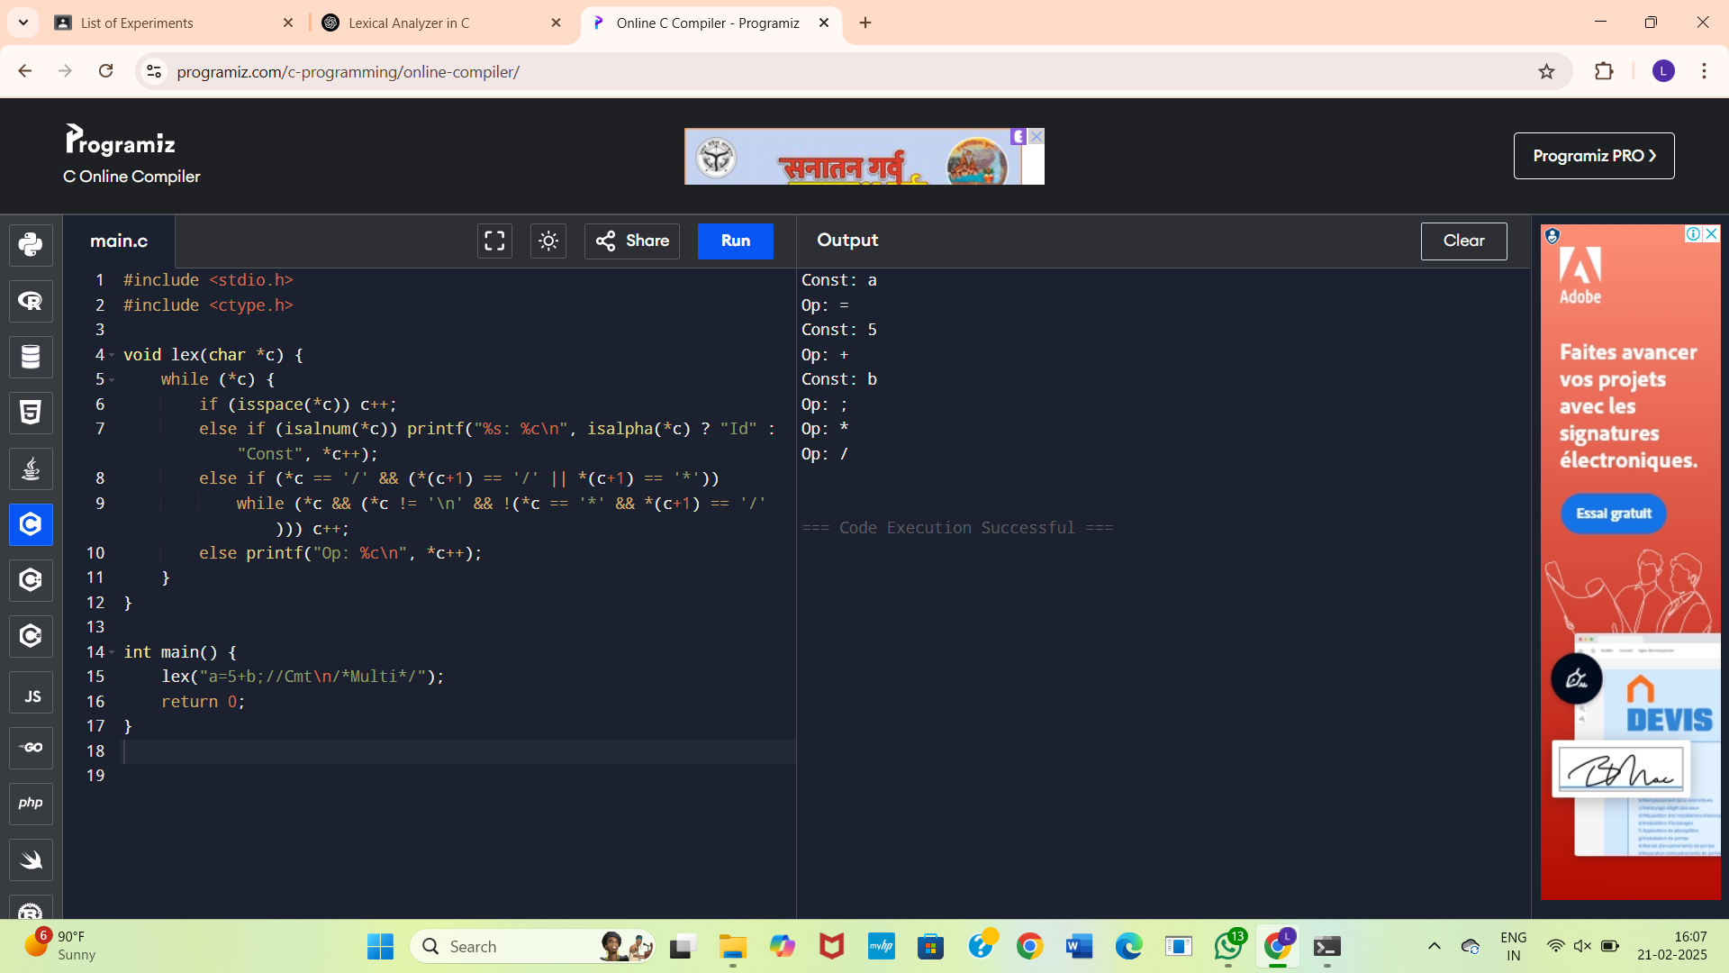

**4. Operator Validator Lexical Analyzer**

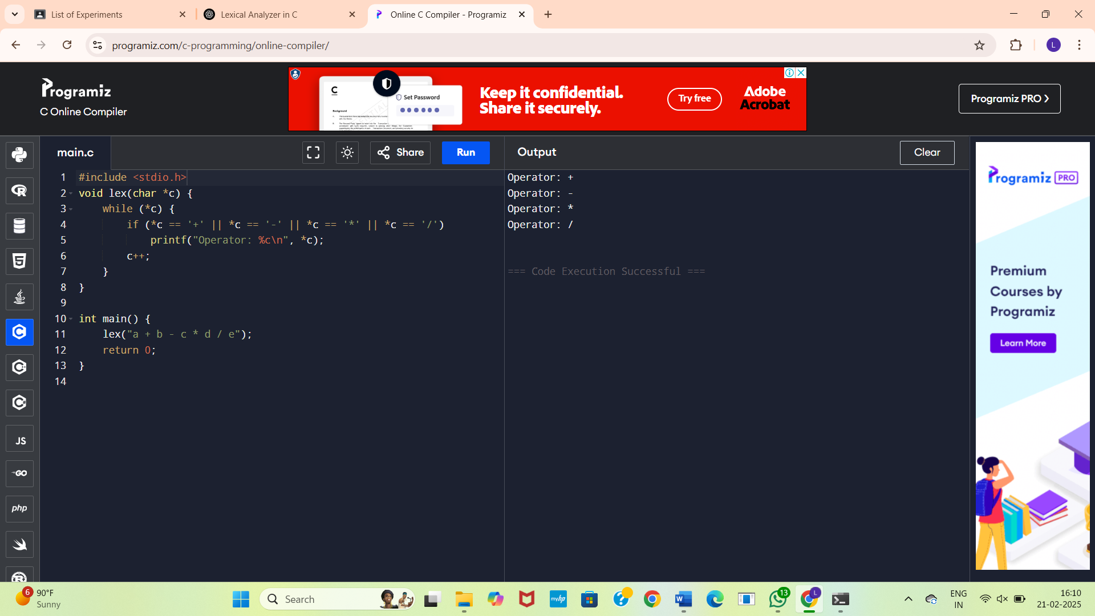

**5.Whitespace and Newline Counter**

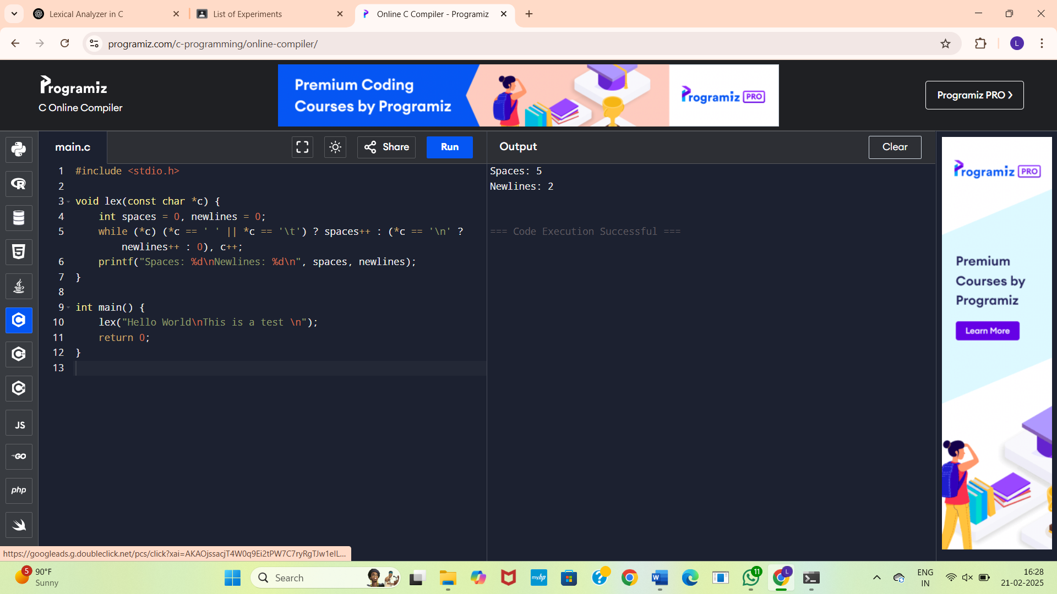

**6.** **lexical Analyzer to test whether a given identifier is valid or not**

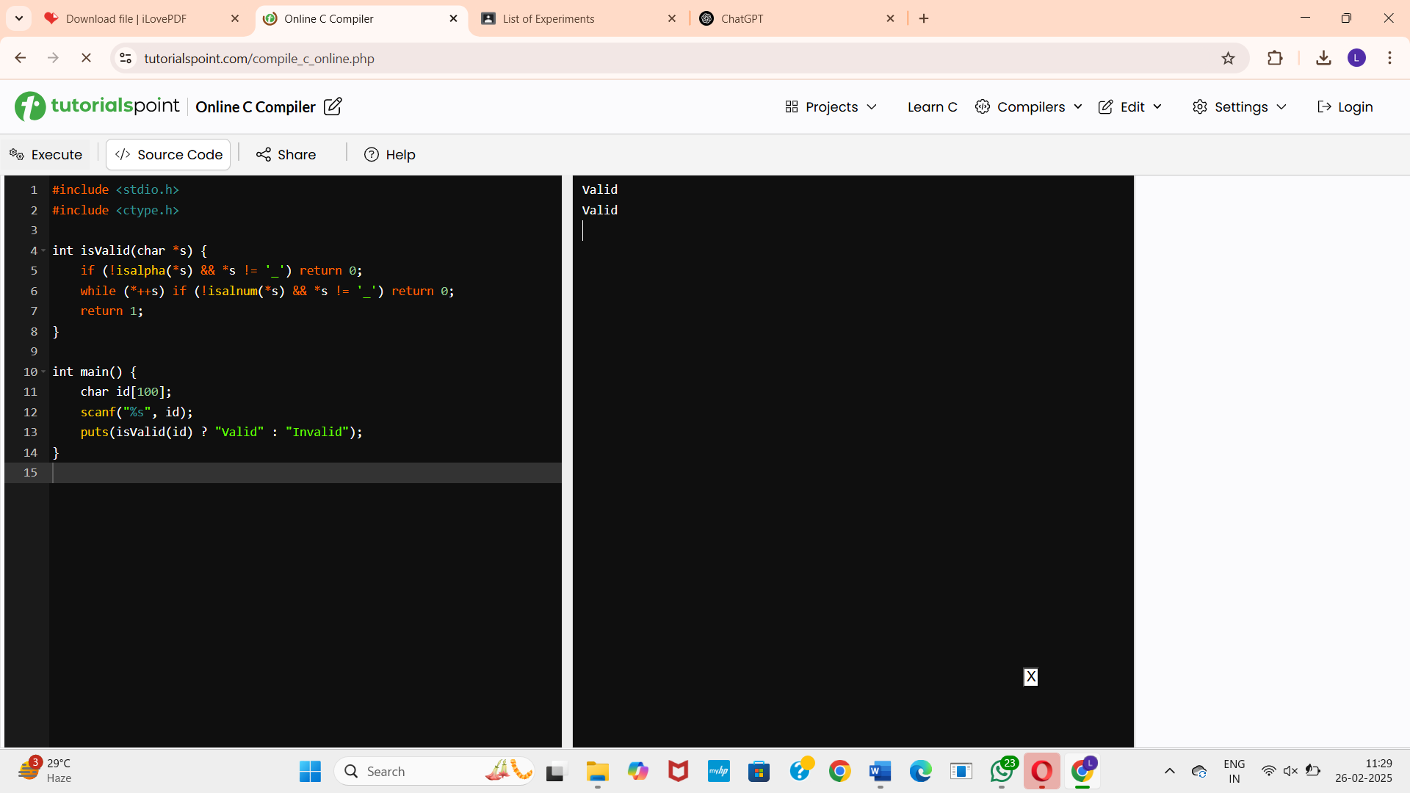

**8.** **predictive parser for the given grammar**

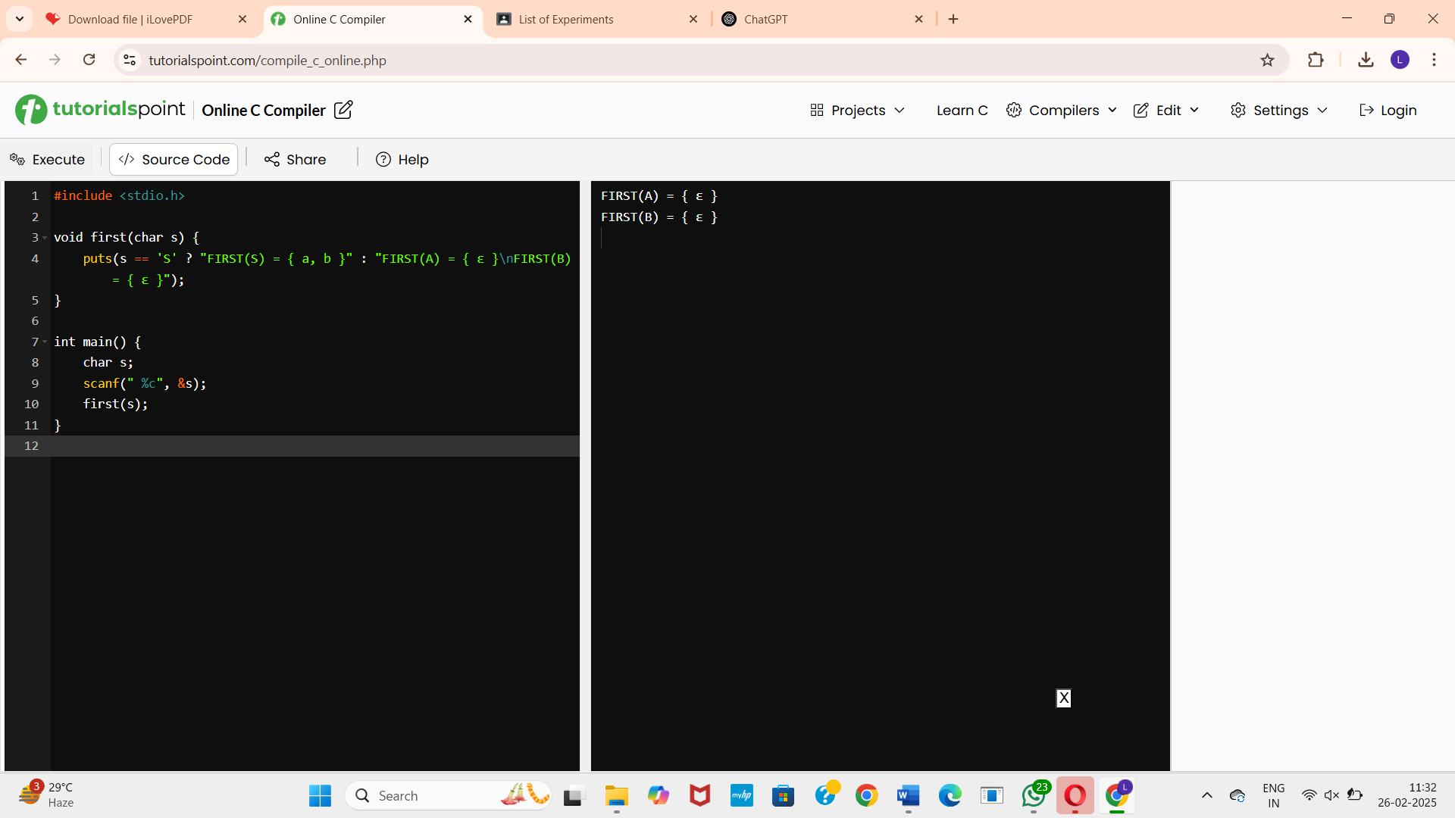

**9.** **to eliminate left recursion from a given CFG**

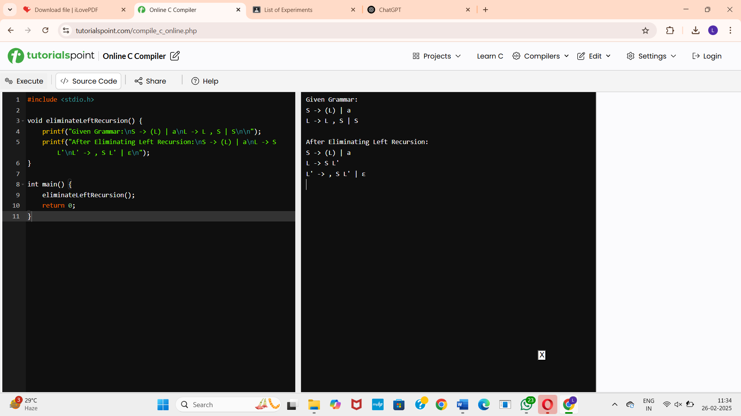

**10.** **program to eliminate left factoring from a given CFG.**

**S → iEtS / iEtSeS / a**

**E → b**

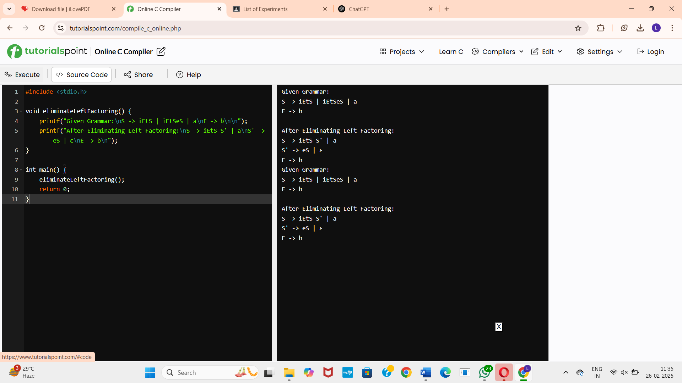

**11.** **Implement a C program to perform symbol table operations.**

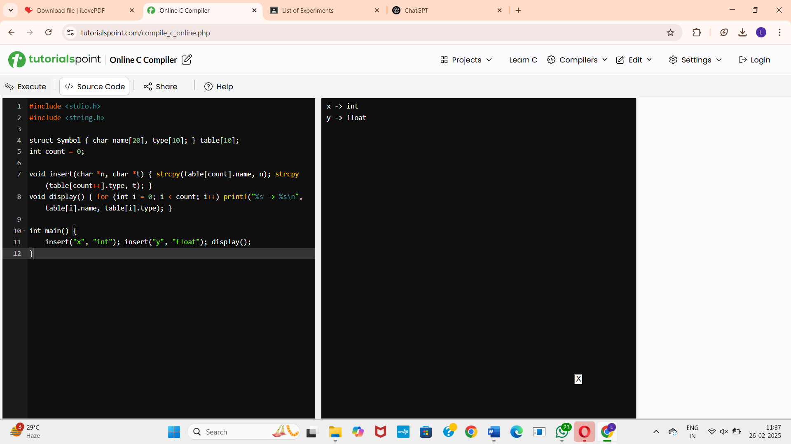

**12.** **Write a C program to construct recursive descent parsing for the given grammar**

**E → TE’**

**E’ → +TE’ / ∈**

**T → FT’**

**T’ → *FT’ / ∈**

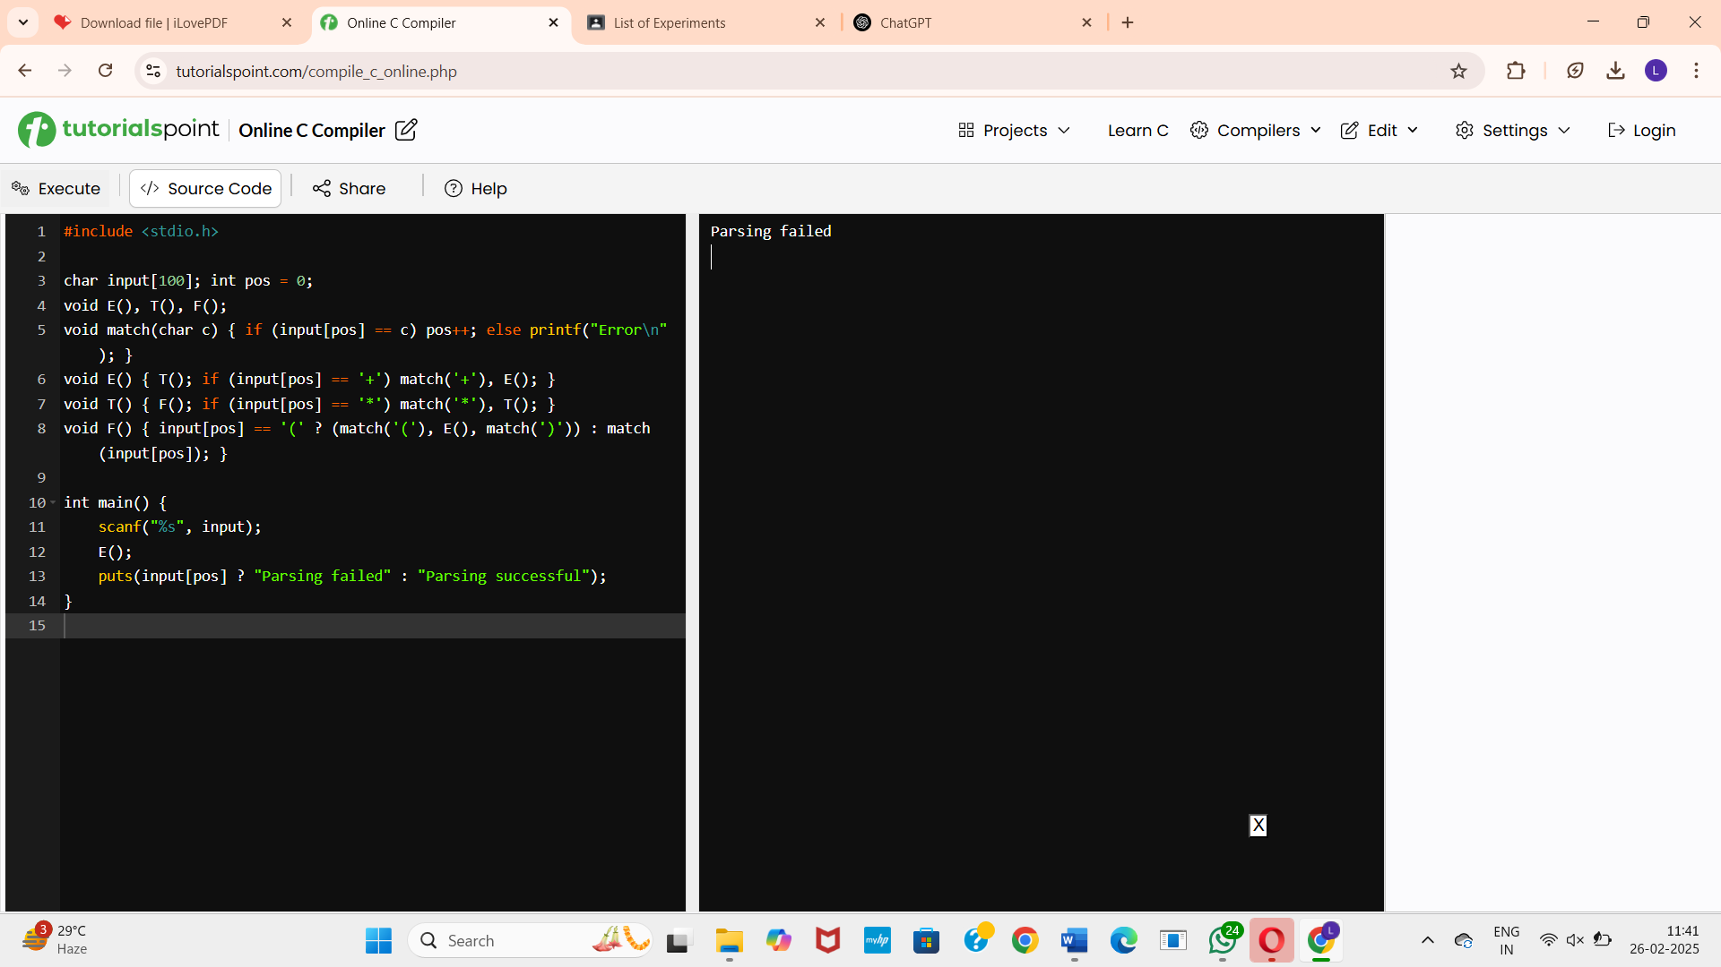

**13. Recursive Descent Parser for Grammar Validation**

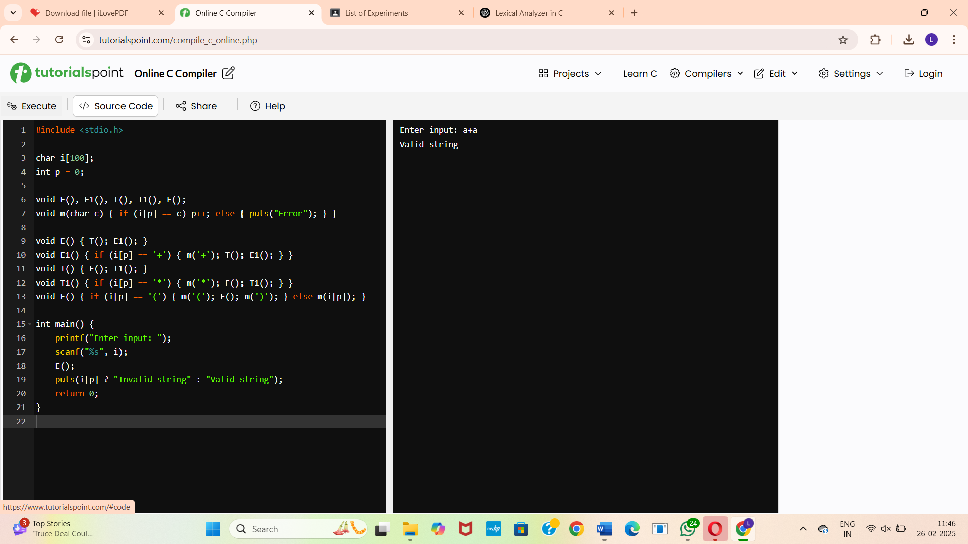

**14.** **Shift-Reduce Parser Implementation in C**

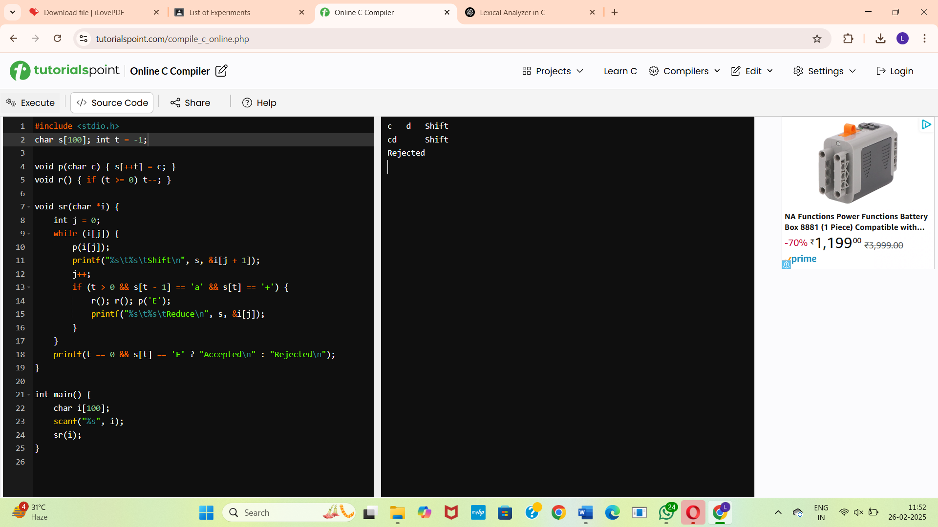

**15.** **Operator Precedence Parsing**

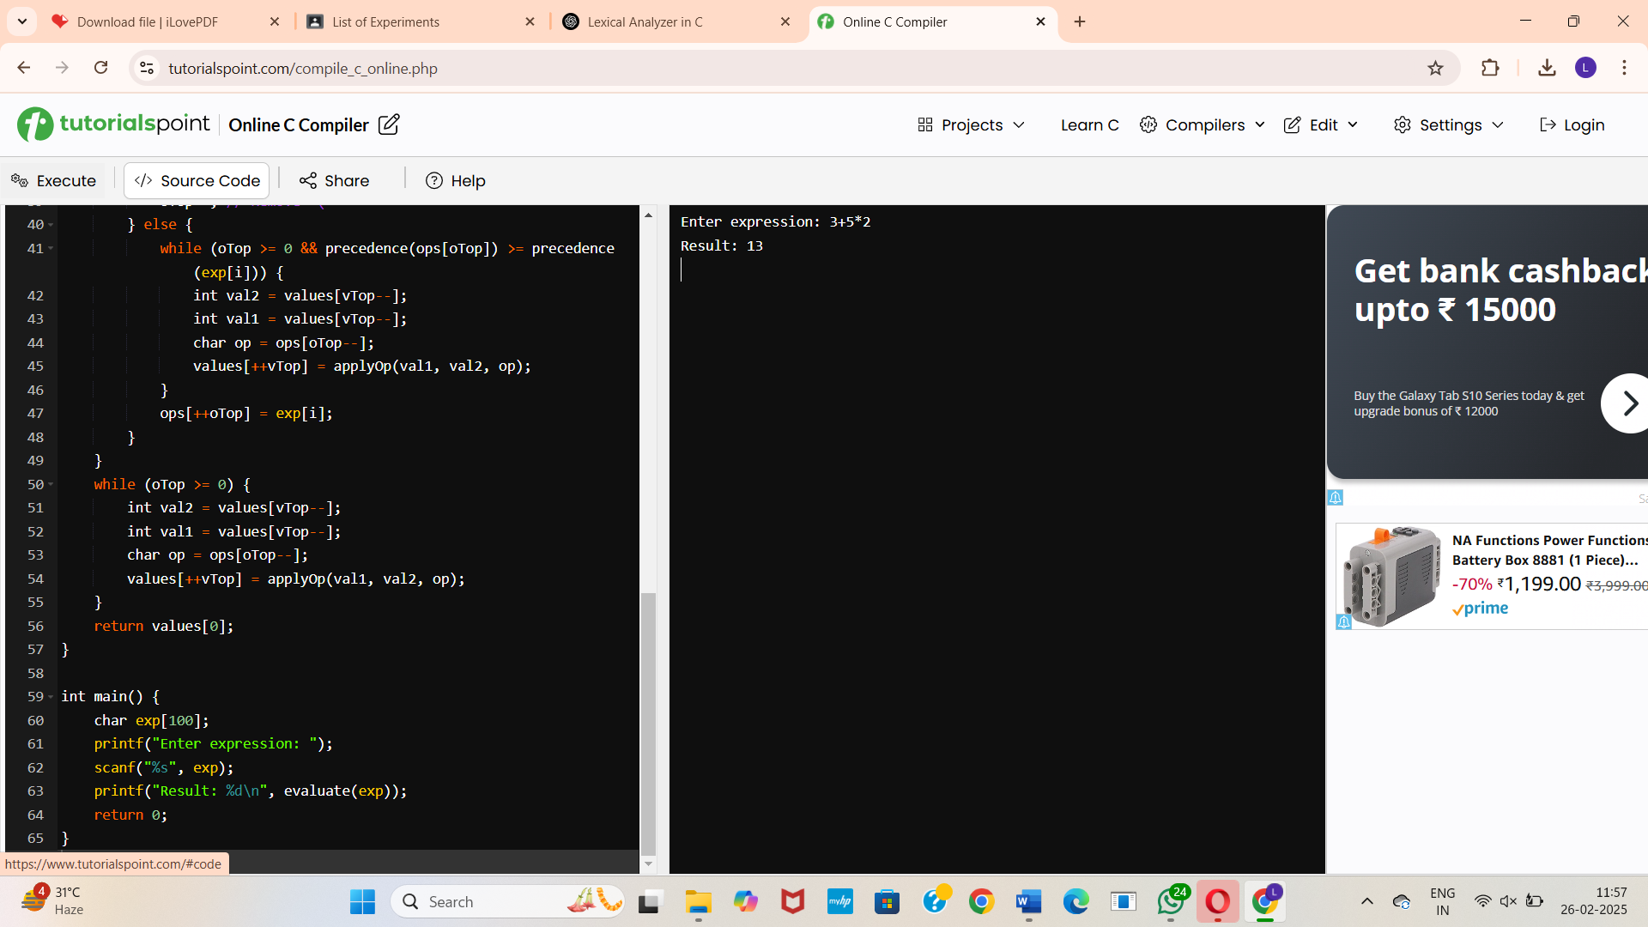

**16. Three Address Code Generation**

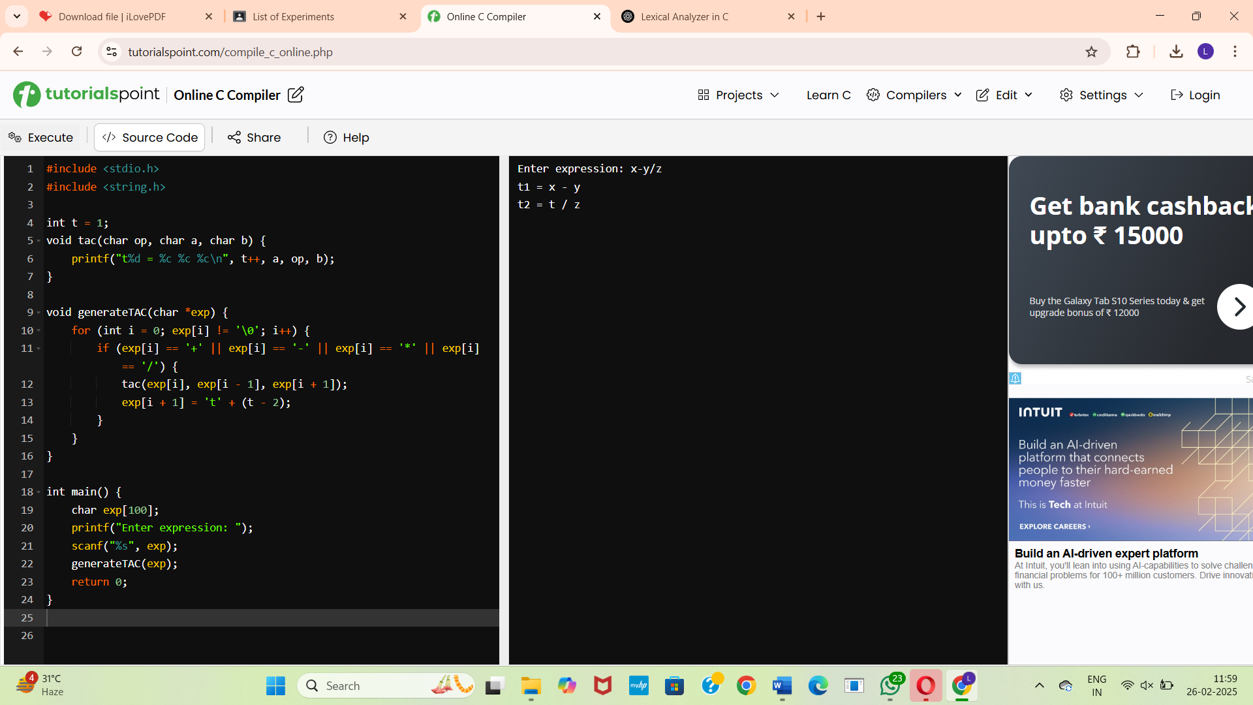

**17.** **Lexical Analyzer to Count Characters, Words, and Lines in a File**

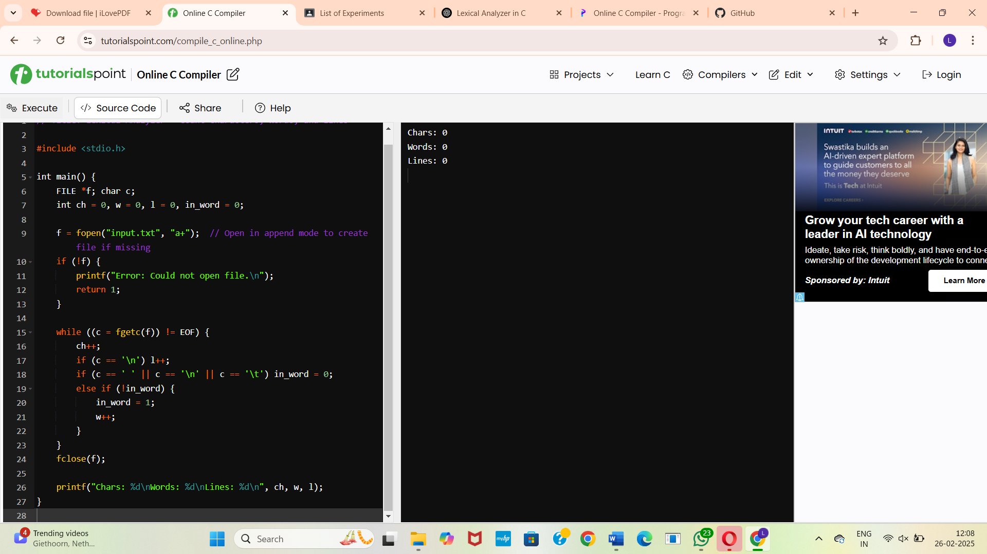

**18.** **Write a C program to implement the back end of the compiler.**

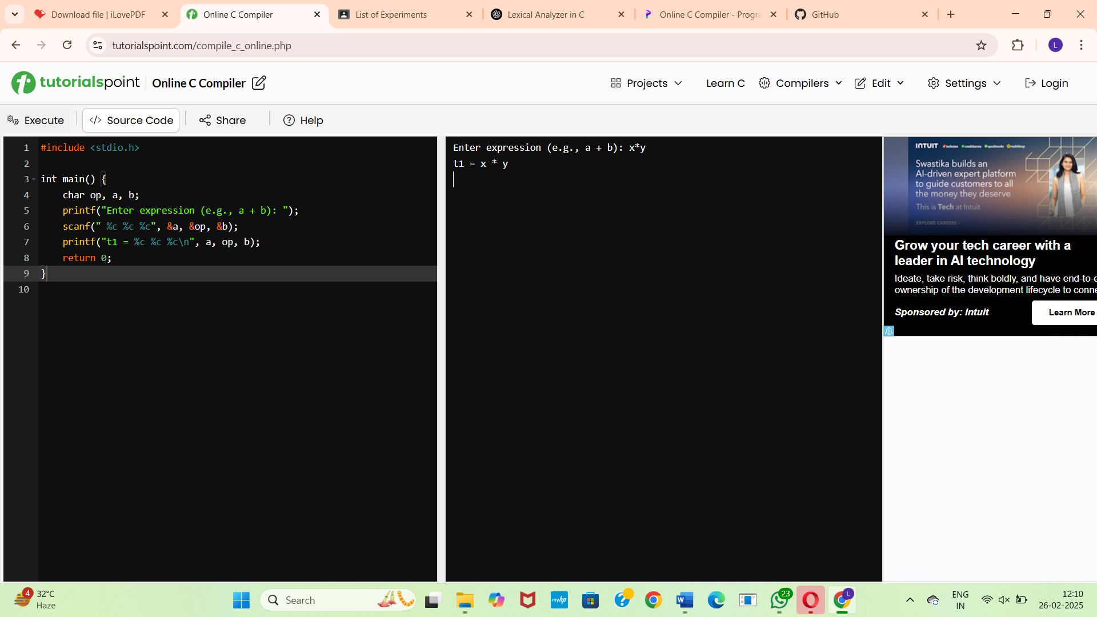

**19.**

**Compute LEADING() - Operator Precedence Parser"**

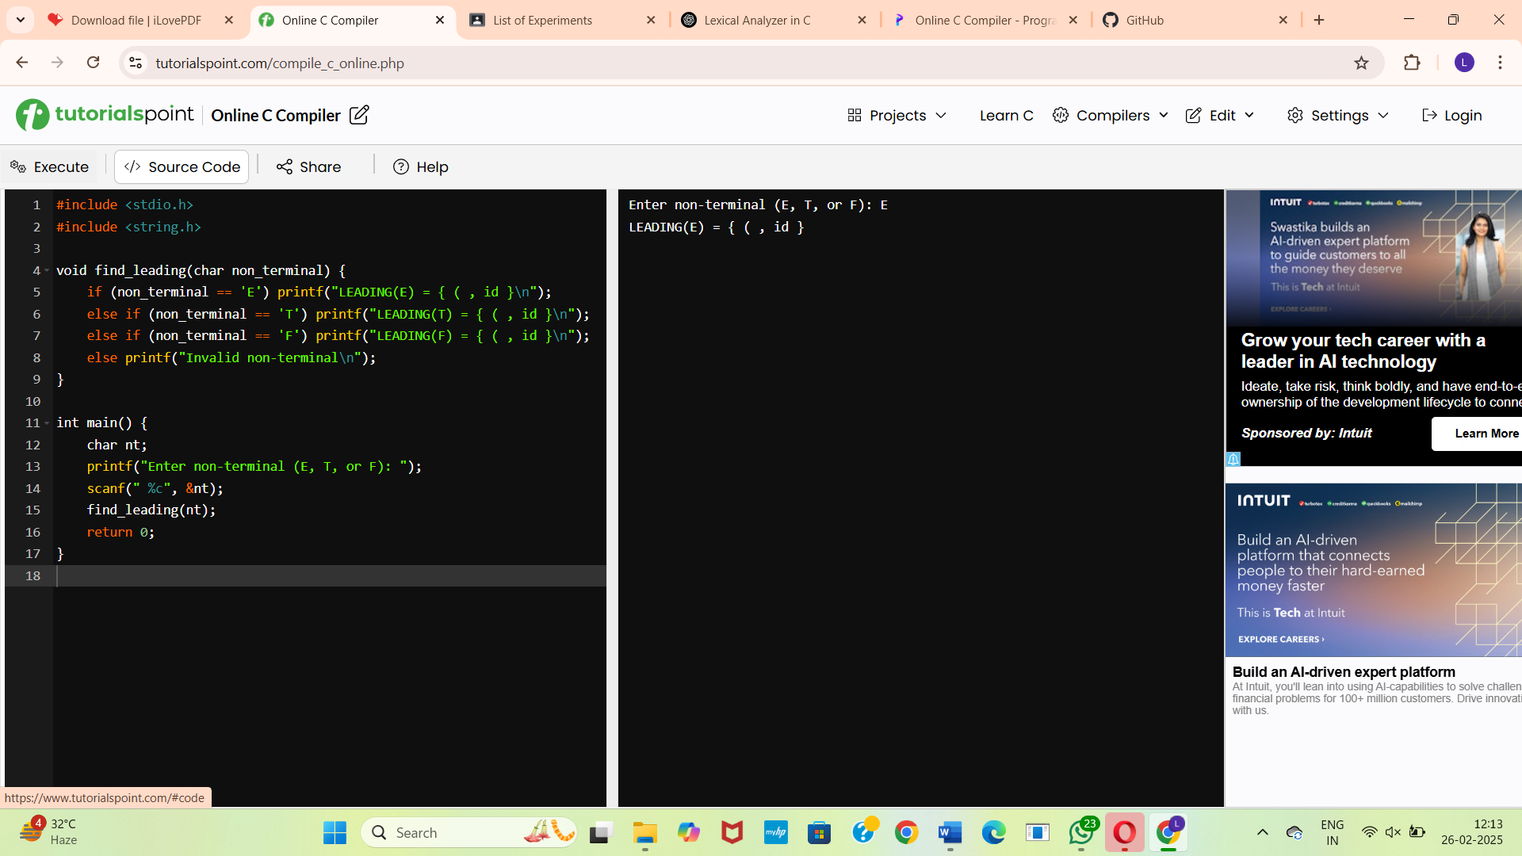

**20. Compute LEADING() and TRAILING() - Operator Precedence Parser**

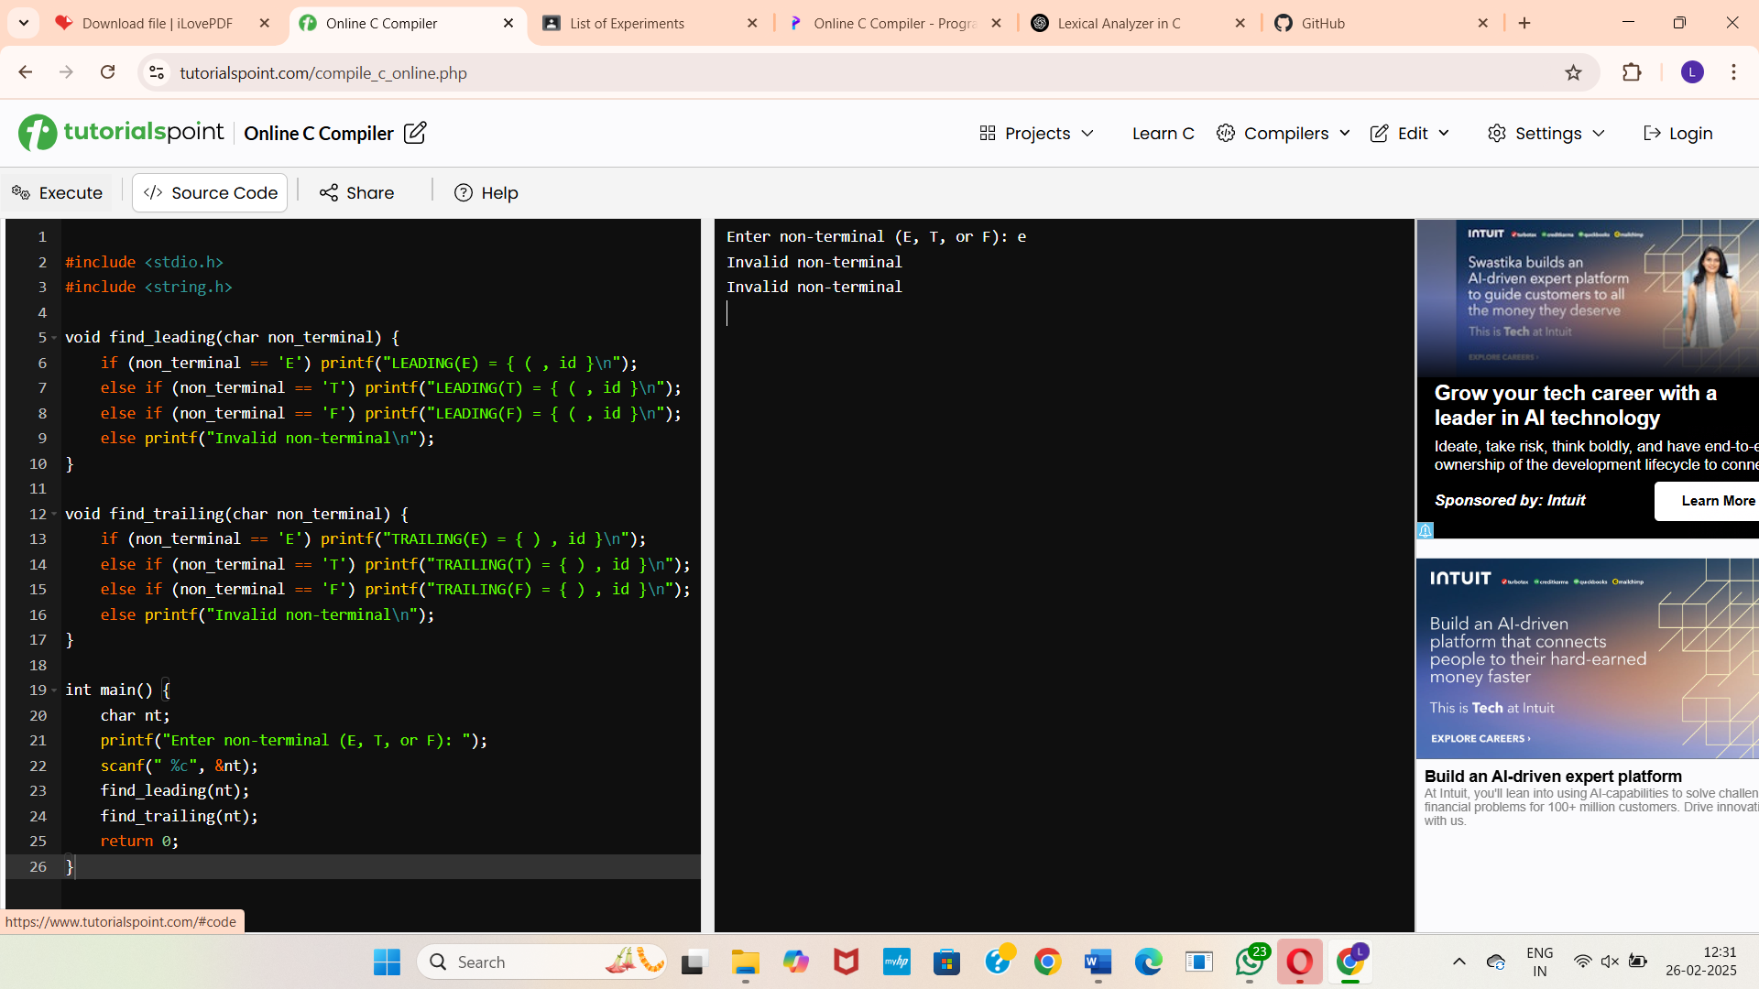

**21. LEX Program to Count Characters, Words, and Lines in a C Source File**

